ML Assignnment 4
Report
-Kushagra Arora
2015049

Value Iteration
Question 1
Code attached.

Question 2
Parameter changed = noise
Noise = 0.01

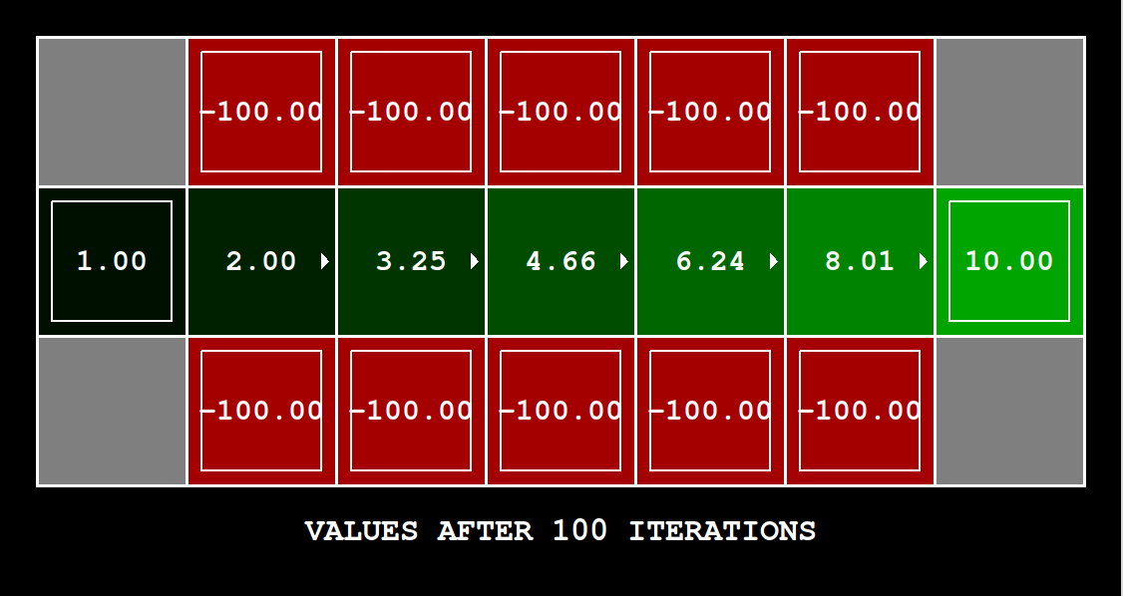
We decreased the noise as it decreases the probability of the agent not following the given path.

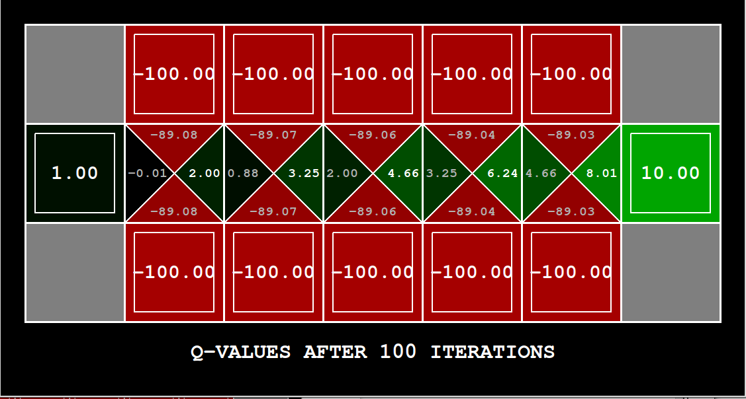

Question 3
- Prefer the close exit(+1), risking the clif

Chosen parameters:
Discount = 0.1
Noise = 0.6
Living Reward = -0.1

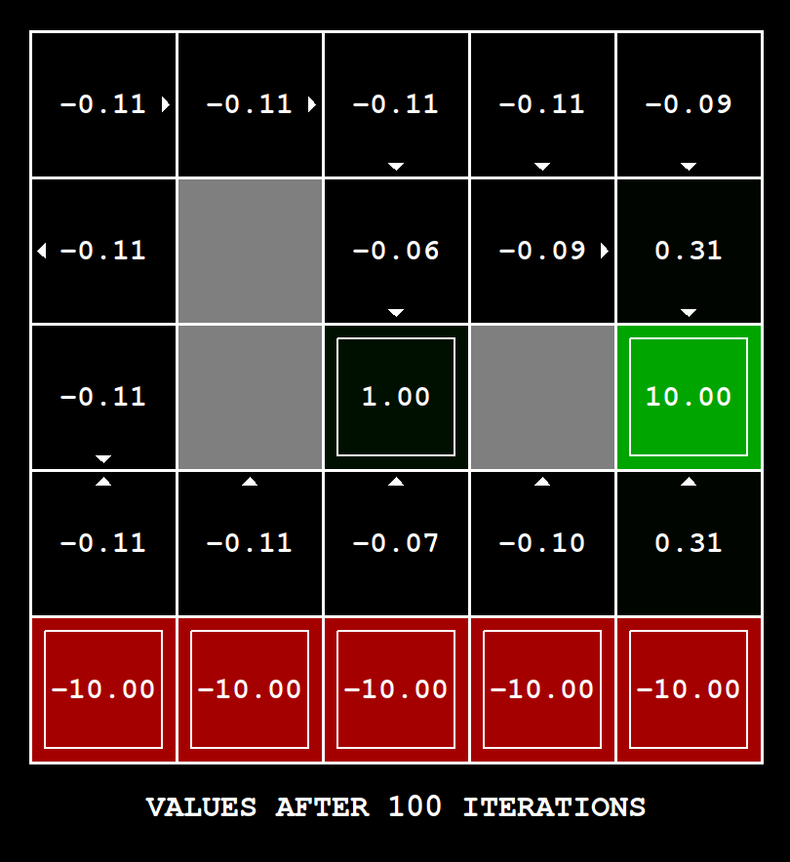

Reason:
A low discount value reduces the impact of the global max_reward in 100 iterations. Moreover, a large noise leads to a greater probabilty of considering the high risk path. A negative living rewarder further slows down the convergence.

Tried parameters:
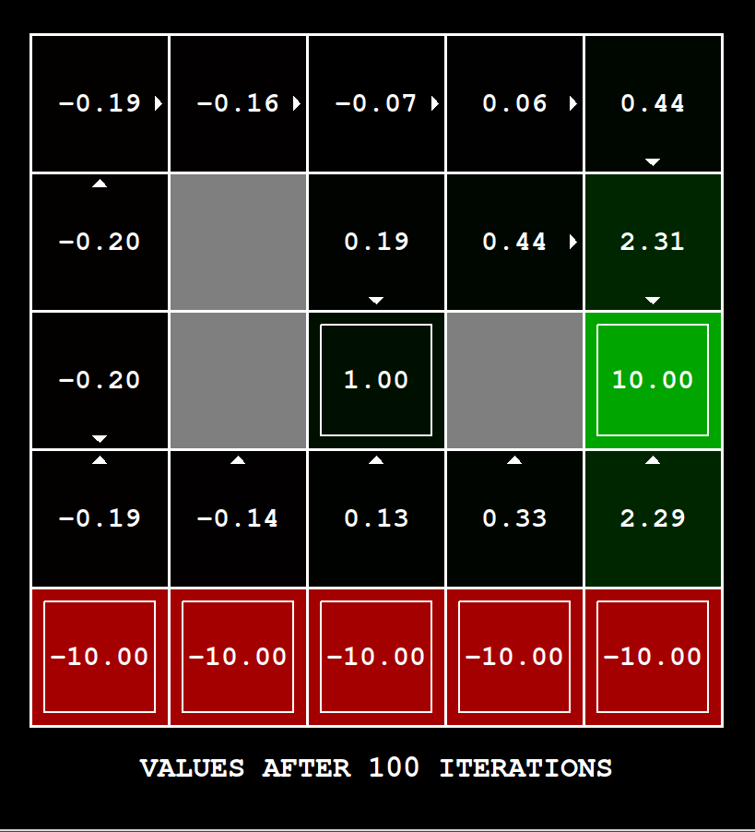

- Prefer the close exit(+1), avoiding the high risk cliff

Chosen parameters:
Discount: 0.05
Noise: 0.01
Living Reward: -0.1

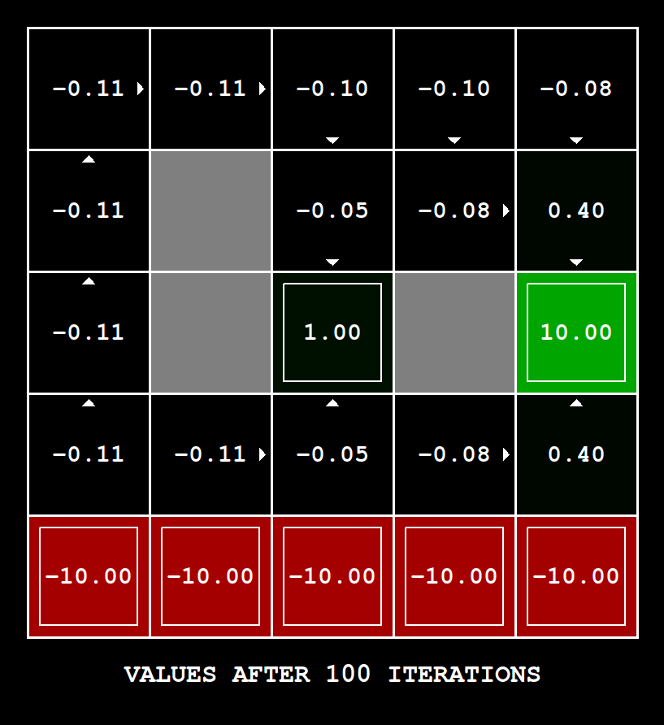

Reason:
Decreasing the noise value decreases the probability of the agent going on a path not desired by the action.

Tried Parameters:

- Prefer the distant exit(+10), risking the high risk cliff

Chosen parameters:
Discount: 0.8
Noise: 0.01
Living Reward: 0.0

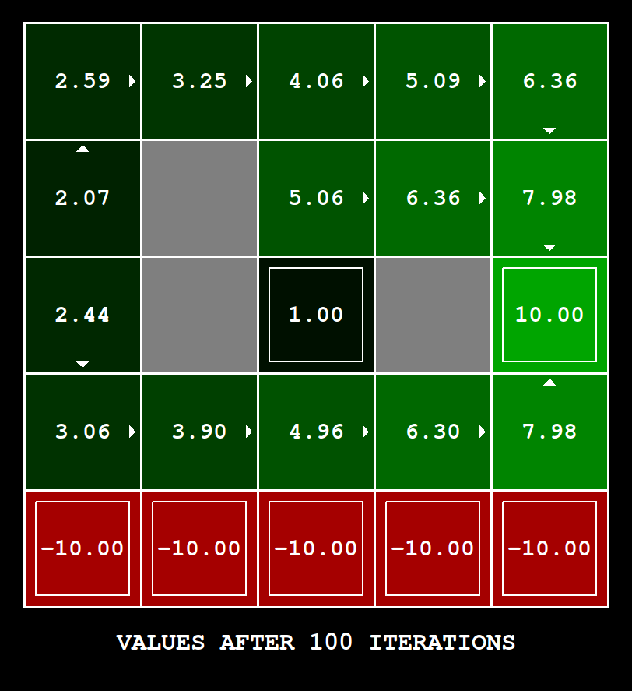

Reason:
A moderately high discount leads to a big impact of the global max (+10) state in 100 iterations. Accompanied with low noise, the impact of the negative states (-100) reduces. A very high discount overcomes the impact of the negative states.

Tried Parameters:

(0.99, 0.01, 0.0)

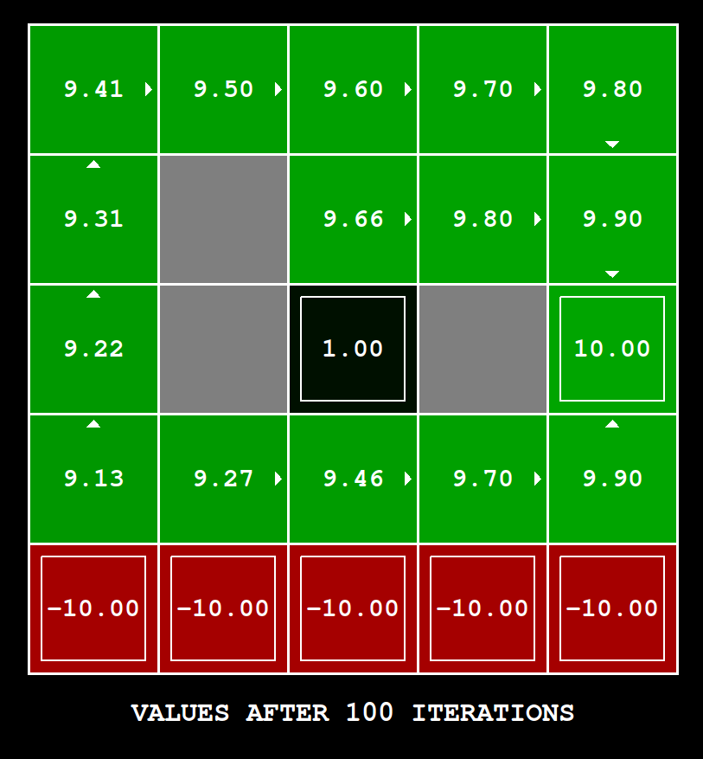

(0.8, 0.3, 0.0)
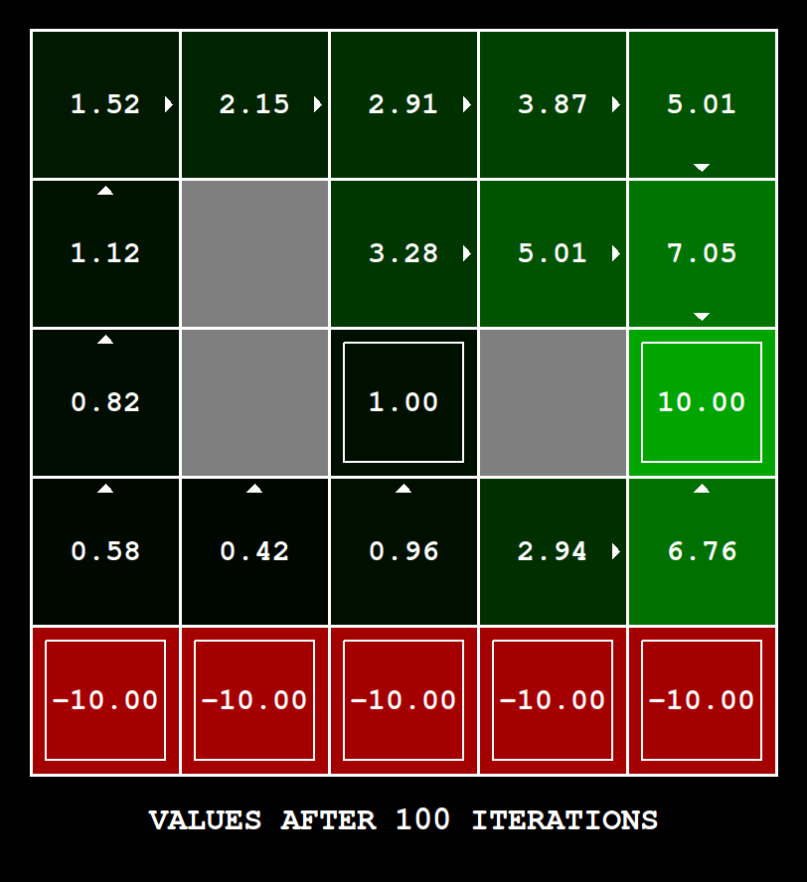

- Prefer the distant exit(+10), avoiding the high risk cliff

Chosen parameters:
Discount: 0.999
Noise: 0.01
Living Reward: 0.0

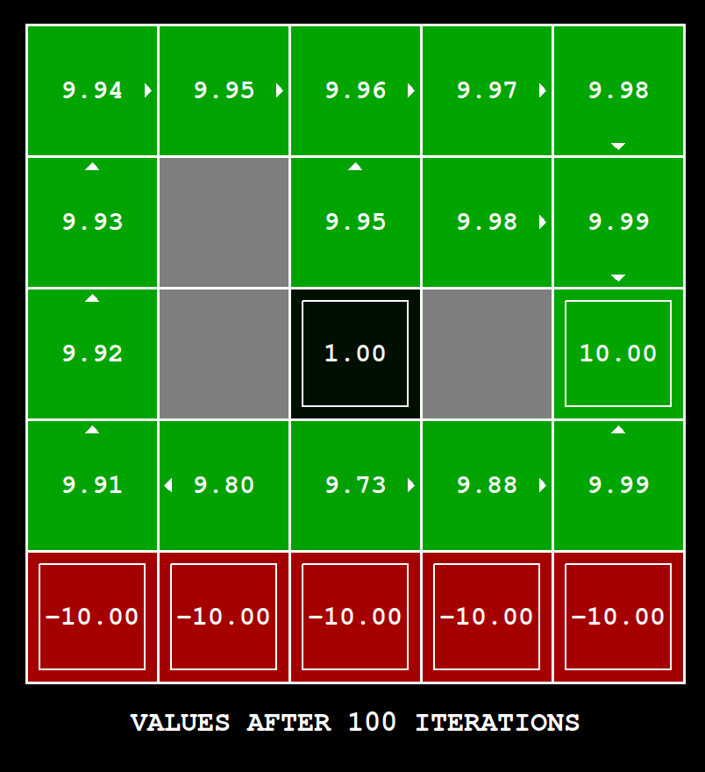
Reason:
Increasing the discount value (with a low noise), the impact of high reward state is high after 100 iterations.

Tried Parameters:
(0.9, 0.01, 0.0)

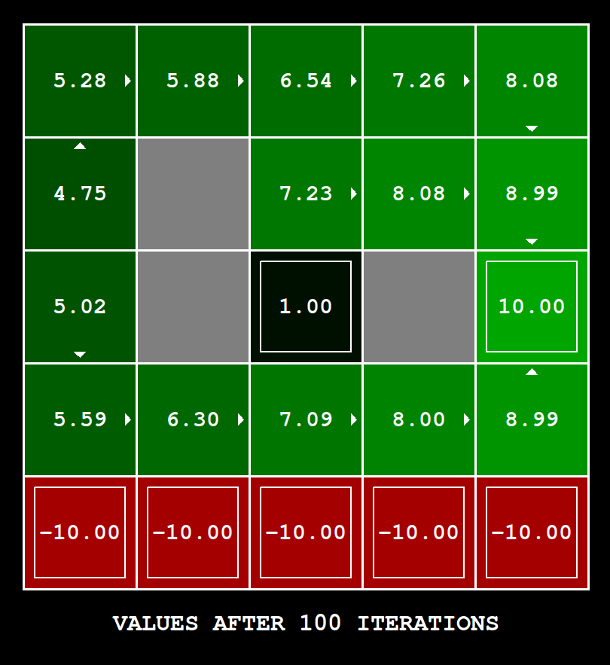

(0.9, 0.2, 0.0) – also works
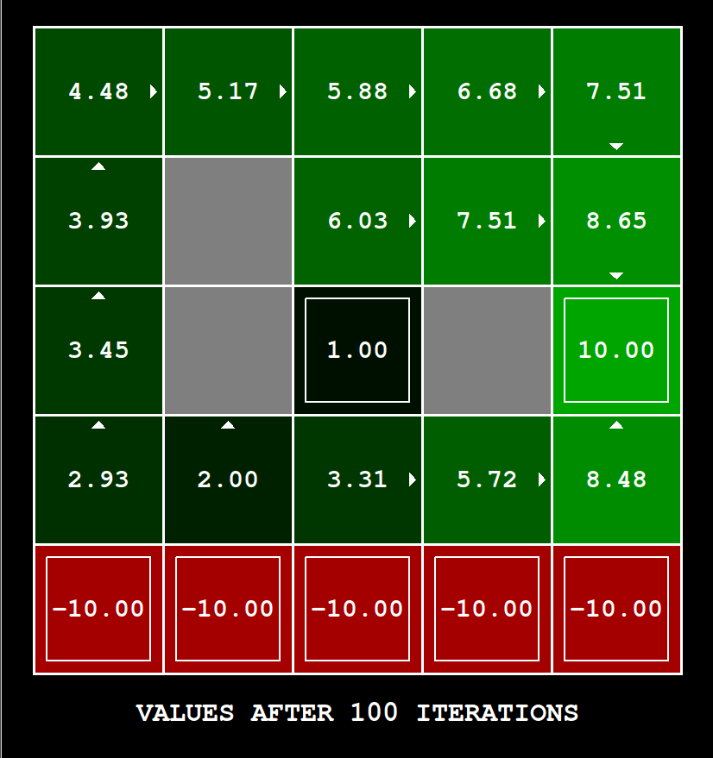

- Avoiding both exits and the cliff

Chosen parameters:
Discount: 0.8
Noise: 0.1
Living Reward: 20.0

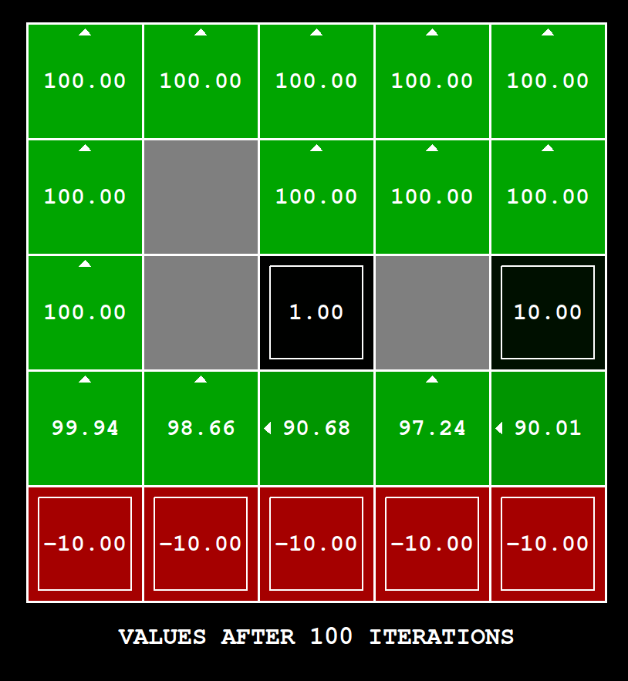

Reason:
Setting an initial reward higher than the terminal states makes the terminal states less important.

K-means

Qualitative Analysis
- Seeds Dataset
  - Plotting actual data
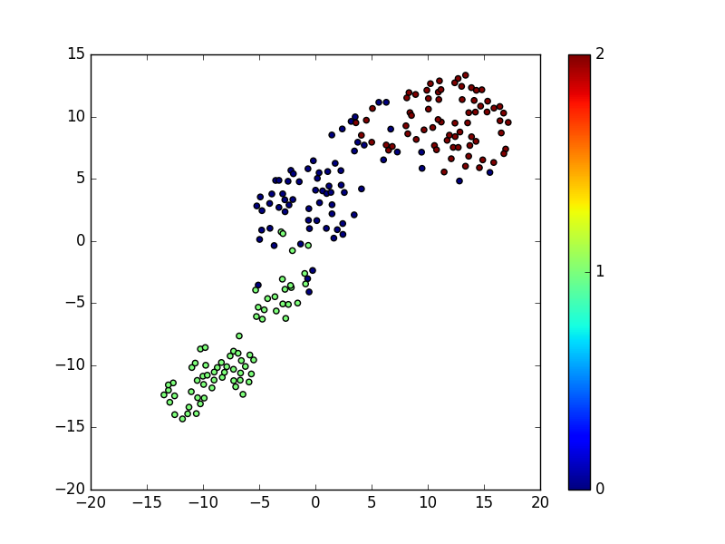
  - K = 2
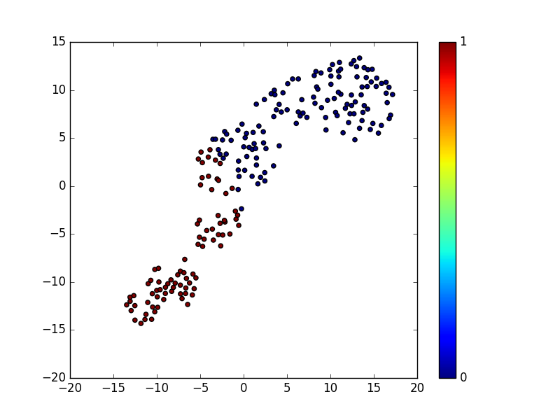

  - K = actual(3)
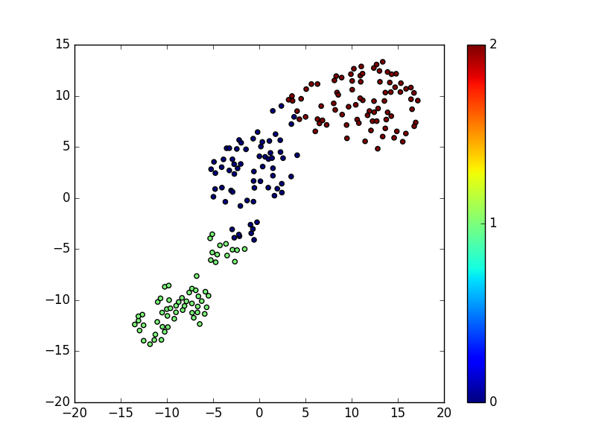
  - K = 12

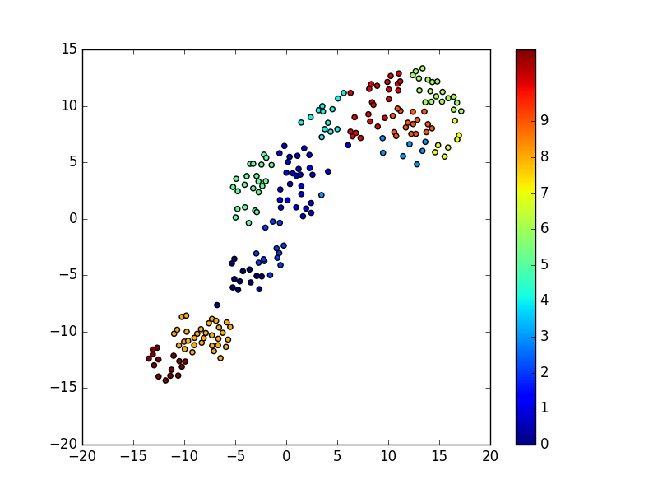

  - Objective Function vs Iteration

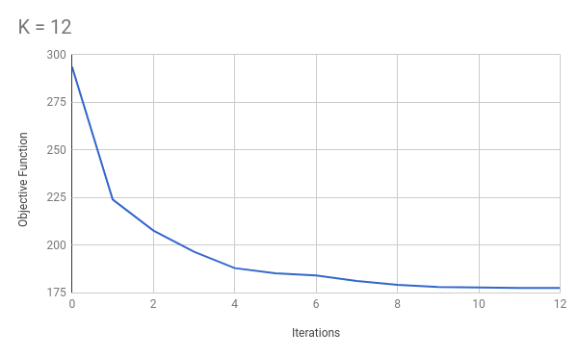

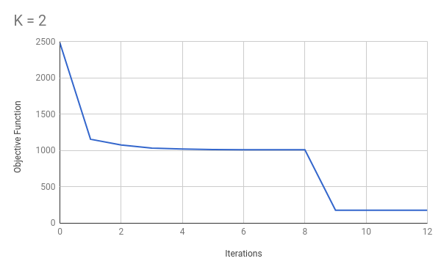

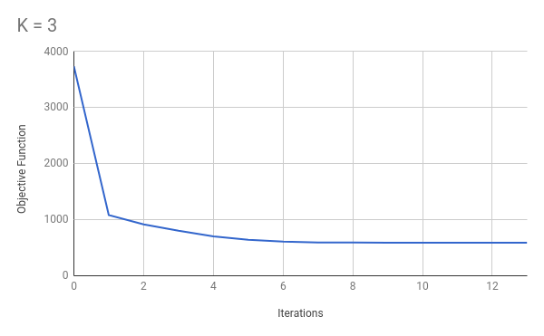

- Vertebral Column
  - Plotting Actual Data
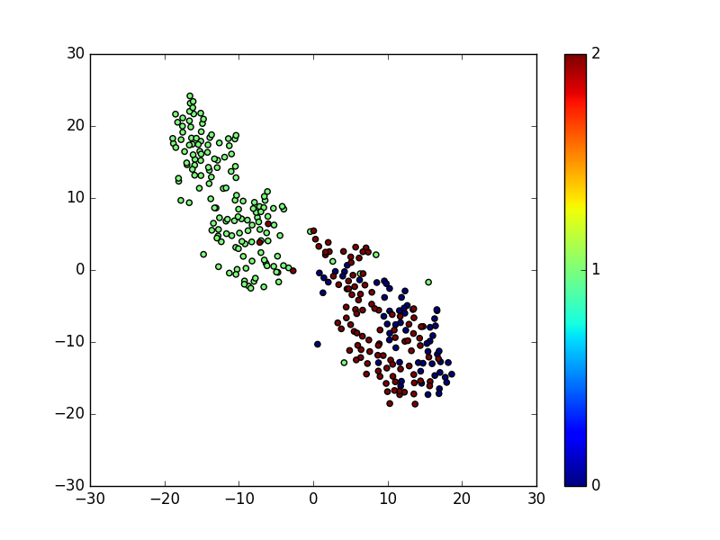
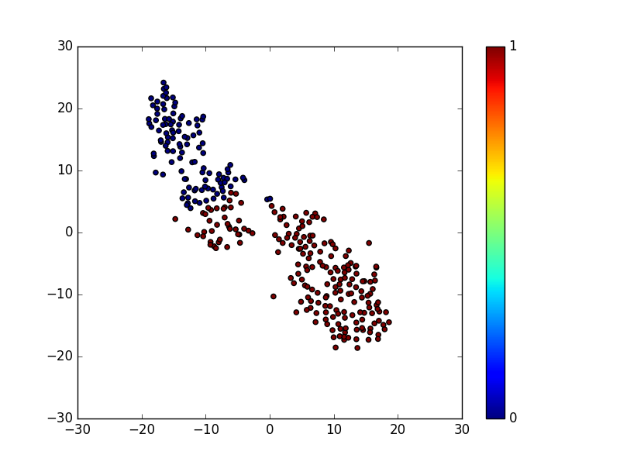
  - K = 2

  - K = actual(3)
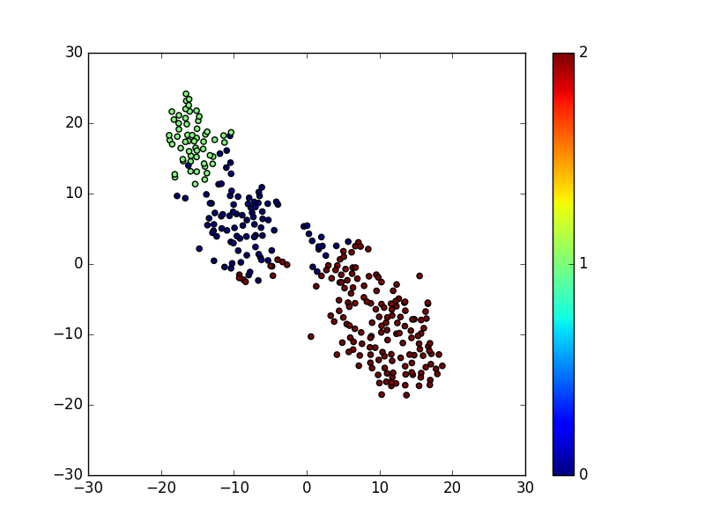
  - K = 12
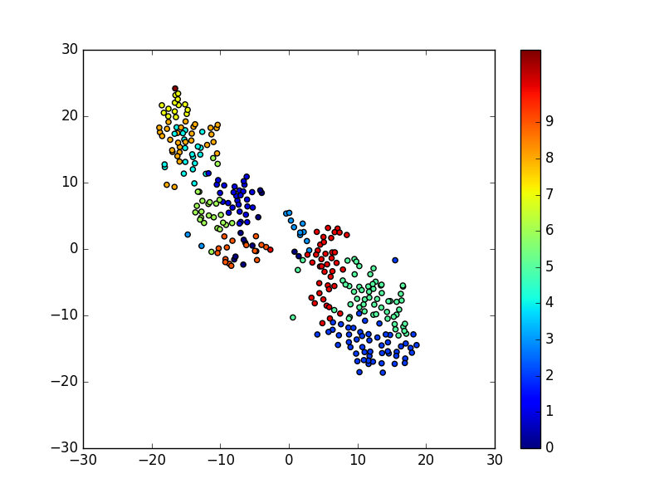

  - Objective Function vs Iteration

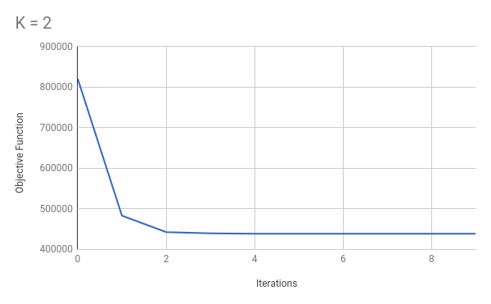

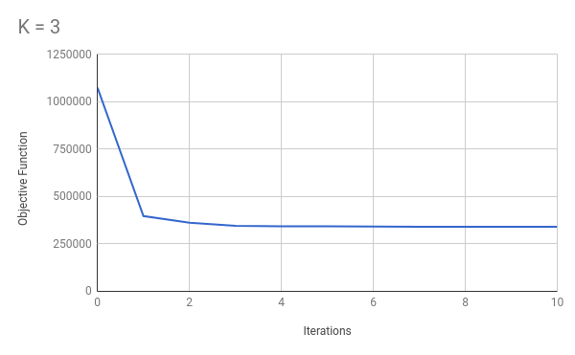

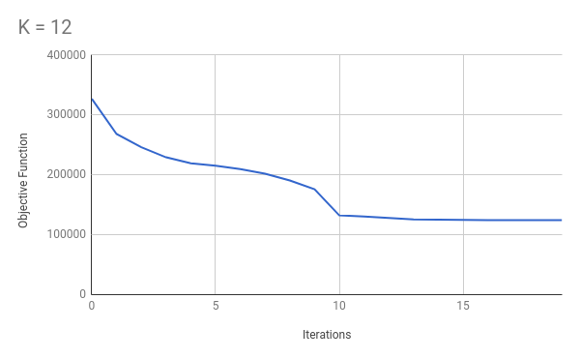

- Image Segmentation
  - Plotting Actual Data
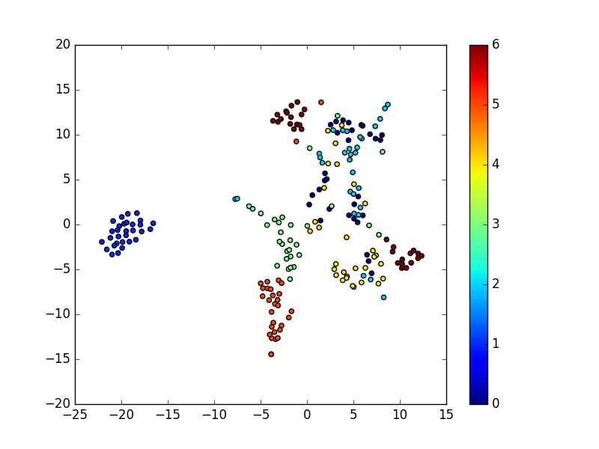
  - K = 2
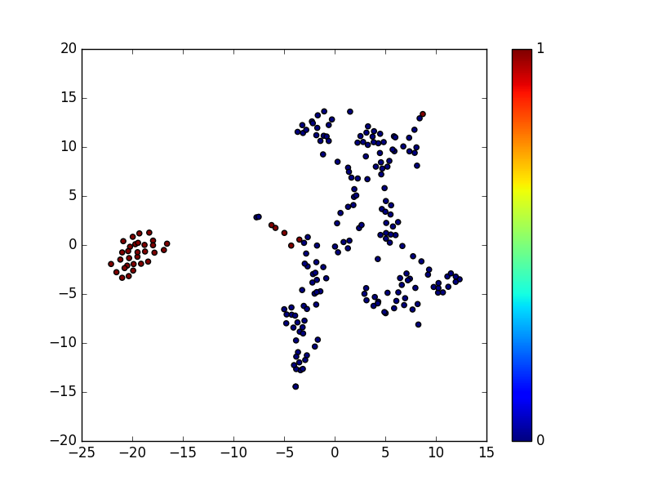

  - K = actual(7)
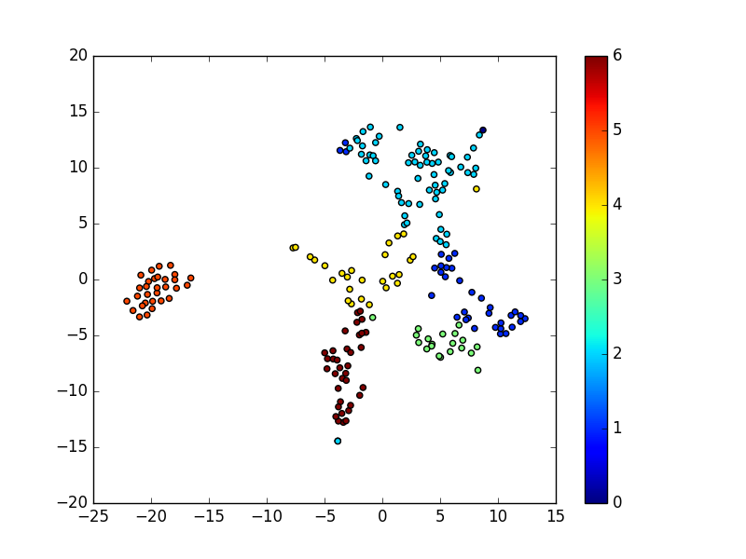
  - K = 12
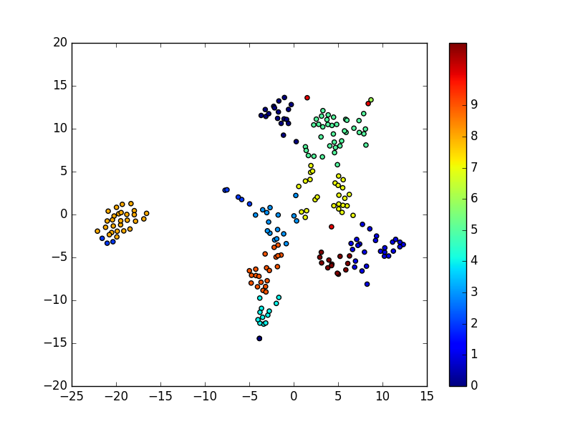

  - Objective Function vs Iteration

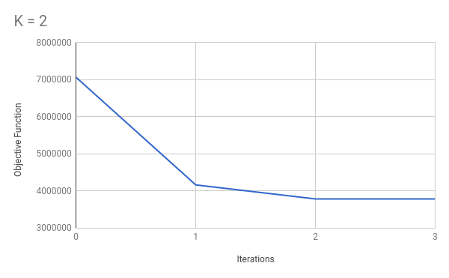

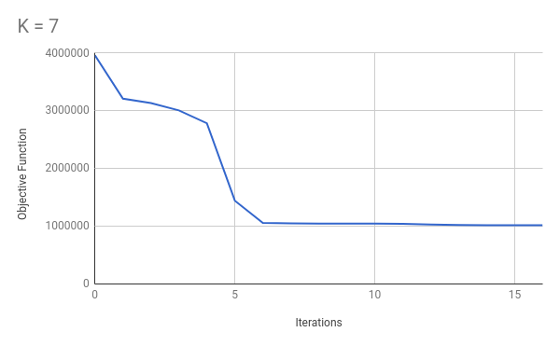

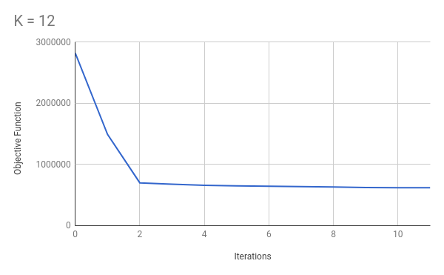

- Iris
  - Plotting Actual Data
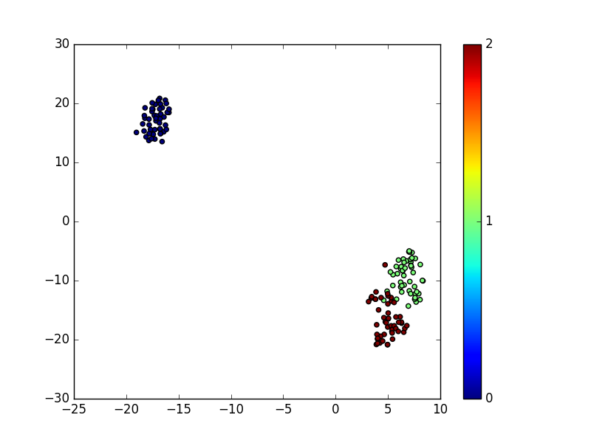
  - K = 2
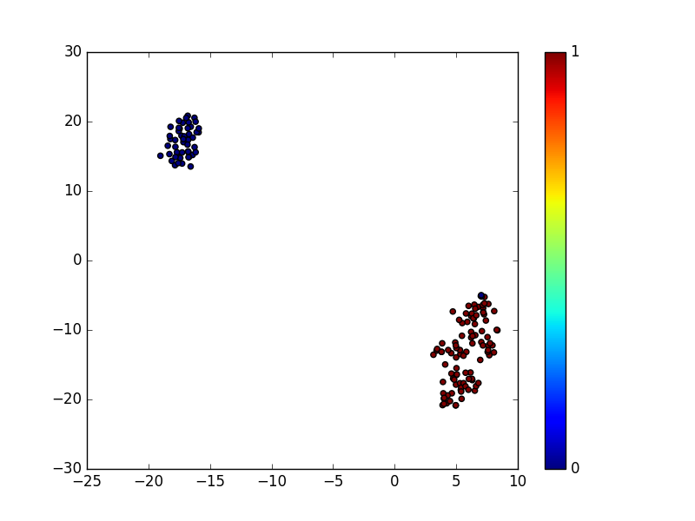

  - K = actual(3)
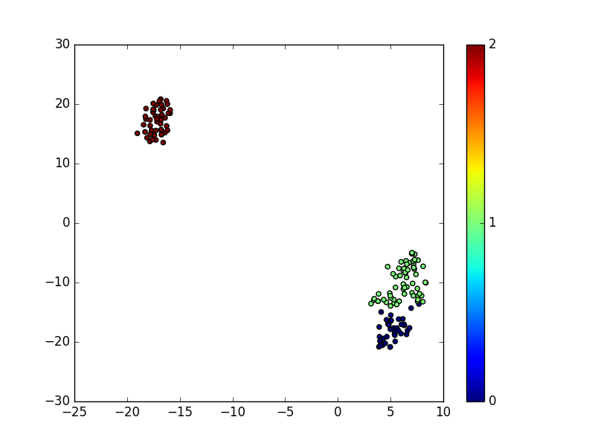
  - K = 12
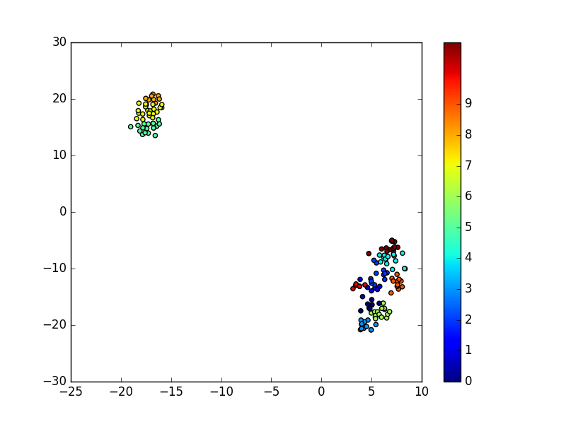

  - Objective Function vs Iteration

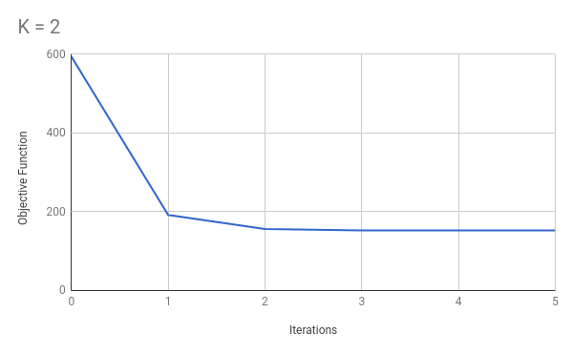

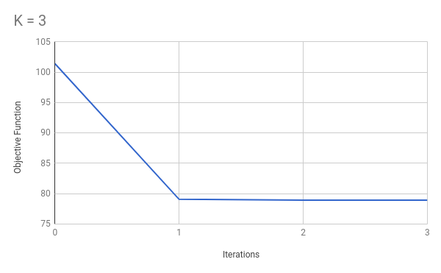

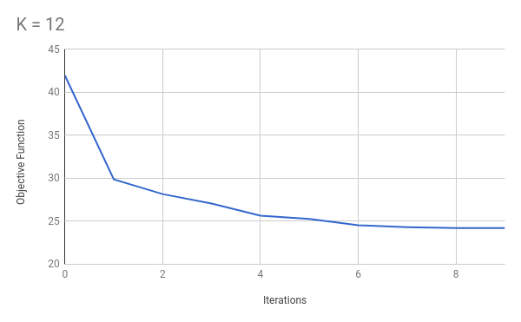

Quantitative Analysis

Data | K = 2 |  |  | K = ACTUAL |  |  | K = 12
Data | ARI | NMI | AMI | ARI | NMI | AMI | ARI | NMI | ARI
Iris | 0.53992182 | 0.67932270 | 0.51936080 | 0.71634211 | 0.74193229 | 0.73311807 | 0.33707250 | 0.64057094 | 0.41638137
Segmen | 0.0995061 | 0.3949393 | 0.18536872 | 0.35927835 | 0.50979284 | 0.45900800 | 0.39029994 | 0.57365020 | 0.49177745
Seeds | 0.46832262 | 0.55224503 | 0.42973890 | 0.71034170 | 0.71006830 | 0.70494101 | 0.29384832 | 0.54699271 | 0.35531004
Vertebrl | 0.29884607 | 0.42496680 | 0.33493495 | 0.31162034 | 0.42096432 | 0.41280224 | 0.16435767 | 0.40984949 | 0.26455241

THEORY QUESTIONS

